Chapter 1
INTRODUCTION

- INTRODUCTION
The Internet of Things is a system of related computer devices, machines, and digital devices, objects, animals or people that are equipped with unique identifiers and the ability to transmit data over the network without the need for human-human or human-human interaction. It is a computational concept that describes the idea of ​​combining physical objects of everyday use with the Internet to enable communication between things and people. IoT describes a world in which almost everything can be connected and communicate in an intelligent way. Devices can be any objects, such as smartphones, Internet televisions, sensors, electronic devices, etc. To collect and exchange data, electronics, software, sensors, and network connectivity are embedded in them. With the increase in the level of sophistication in basic devices and growing concerns about environmental requirements to develop an intelligent system that is self-aware of the environment and can analyze and react at its own discretion without the need to use the human factor, called Automated Systems. The proposed system focuses on the development of an online home automation system based on the Internet of Things, which allows the user to automate all devices and home appliances and connect them to ensure smooth control over each page of their home. The data can be used to predict non-standard user behavior by developing a machine learning algorithm, and then the prediction results can be used to increase the intelligence of the smart home system. The designed system not only transmits data from the sensor, but also processes them as required, for example, turns on the light when it gets dark, and allows the user to control the household appliances from anywhere. The cloud is used to send data from sensors via the Wi-Fi module, and then implements a machine learning algorithm that also determines the efficiency of electronic devices, serves to achieve power control and local data exchange that provide user interface, storage all information relating to of a specific house and asking for information about the functions of a single household appliance. To enable or disable the Google LED assistant, you can use it to send voice commands.

  - What is IoT
Internet of Things (IoT) is an ecosystem of connected physical objects that are accessible via the Internet. The "thing" in IoT can be a person with a heart monitor or car with built-in sensors, i.e. objects that have been assigned an IP address and that can collect and transmit data through the network without manual help or intervention. The technology built into objects helps them interact with internal states or the external environment, which in turn influences the decisions made.
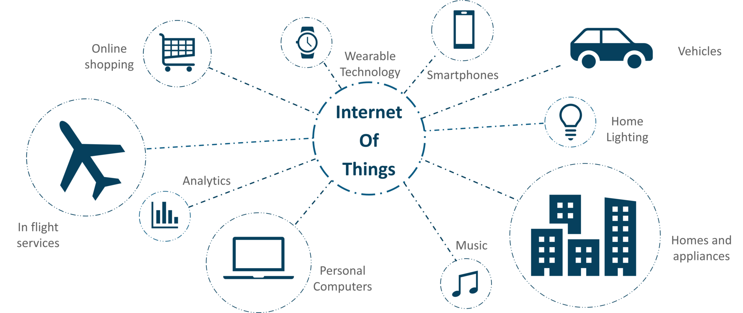
Fig 1.1: IoT Architecture
  - What is Home Automation
Home automation is part of the 'Internet of Things', also known as IoT. The way in which devices and devices can be networked to provide us with a seamless control over all aspects of your home and beyond. Home automation has been around for many decades in terms of lighting and simple device control. Recently, technology has caught up with the idea of ​​a connected world at the touch of a finger or a simple voice command for Alexa, Google Assistant, Siri, and Cortana. The dream of making a smart home is now a reality. Intelligent home and home automation are quite interchangeable, in fact, if you study what is a smart home, most of the same results will appear.
With home automation, you can dictate how the device should respond when it should respond and why it should respond. Set the schedule to determine when devices should turn on and off. Based on your personal preferences, you can control time, money and convenience.
New home automation technology can send notifications to your smartphone and notify you about unforeseen events when you are away from home. Such as water leaks, guests at the front of the door, and even remote turning on lights when you are on vacation, at work or anywhere else.
Grab your iPhone or Android to remotely control and change settings at home using home automation applications. Now, there is a craze of automation and more than one-third of American consumers own two or more smart home appliances and grows.
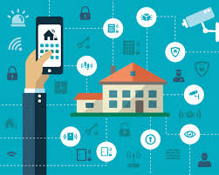
Fig 1.2: Home Automation using IoT
  - Why IoT is Important
IoT IS immensely important because it is the first real evolution of the Internet—a leap that will lead to revolutionary applications that have the potential to dramatically improve the way people live, learn, work, and entertain themselves. Already, IoT has made the Internet sensory (temperature, pressure, vibration, light, moisture, stress), allowing us to become more proactive and less reactive.
In addition, the Internet is expanding into places that until now have been unreachable. Patients are ingesting Internet devices into their own bodies to help doctors diagnose and determine the causes of certain diseases. Extremely small sensors can be placed on plants, animals, and geologic features, and connected to the Internet. At the other end of the spectrum, the Internet is going into space.
  - IoT Applications
When we crossed the threshold of connecting more objects than people to the Internet, a huge window of opportunity opened for the creation of applications in the areas of automation, sensing, and machine-to-machine communication. In fact, the possibilities are almost endless. The following examples highlight some of the ways IoT is changing people’s lives for the better.
    - Mumbai: A Tale of Two Cities
The number of people from Dharavi pay for municipal-grade water is $1.12 per cubic meter. This compares to $0.03 for residents of Warden Road. The injustice is clear: the poor people of Mumbai pay 37 times more for water (a basic human necessity) The main source of the disparity is the higher cost of delivering utility services to poorer neighborhoods because of infrastructure inefficiencies, problems such as leaks, and theft.
IoT, because of its ubiquitous sensors and connected systems, will provide authorities with more information and control to identify and fix these problems. This will allow utilities to operate more profitably, giving them extra incentive to improve infrastructures in poorer neighborhoods. More efficiency will also allow for lower prices, which, in turn, will encourage those taking services for free to become paying customers.
    - Better Quality of Life for Elderly
The world’s population is aging. In fact, approximately 1 billion people age 65 and older will be classified as having reached “non-working age” by the middle of the century. IoT can significantly improve the quality of life for the surging number of elderly people. For example, imagine a small, wearable device that can detect a person’s vital signs and send an alert to a healthcare professional when a certain threshold has been reached, or sense when a person has fallen and can’t get up.

  - Challenges and Barriers to IoT
Several barriers, however, have the potential to slow the development of IoT. The three largest are
the deployment of IPv6, power for sensors, and agreement on standards.
DEPLOYMENT OF IPv6: The world ran out of IPv4 addresses in February 2010. While no real impact has been seen by the public, this situation has the potential to slow IoT’s progress since the potentially billions of new sensors will require unique IP addresses. In addition, IPv6 makes the management of networks easier due to auto-configuration capabilities and offers improved security features.
SENSOR ENERGY: For IoT to reach its full potential, sensors will need to be self-sustaining. Imagine changing batteries in billions of devices deployed across the planet and even into space. Obviously, this isn’t possible. What’s needed is a way for sensors to generate electricity from environmental elements such as vibrations, light, and airflow. In a significant breakthrough, scientists announced a commercially viable nanogenerator—a flexible chip that uses body movements such as the pinch of a finger to generate electricity—at the 241st National Meeting & Exposition of the American Chemical Society in March 2011.
STANDARDS: While much progress has been made in standards, more is needed, especially in the areas of security, privacy, architecture, and communications. IEEE is just one of the organizations working to solve these challenges by ensuring that IPv6 packets can be routed across different network types. It is important to note that while barriers and challenges exist, they are not insurmountable. Given the benefits of IoT, these issues will get worked out. It is only a matter of time.

  - Literature Survey
- Title: Internet of Things based Home Automation System.
Author: Soumya S, Malini Chavali, Shuchi Gupta, Niharika Rao
Work implemented
This paper presents a home automation system based on internet of things which works successfully by connecting various appliances and providing the user remote control of the lighting system of their home. The objective is accomplished by using a Raspberry Pi which is connected to different sensors and run by a python program. The lights are programmed to turn off automatically if there is no one inside the room or if a person enters the room but the room is bright. JavaScript application is used to control the relay from anywhere. The proposed system is flexible, cost-effective and energy efficient. This system functions on its own as well as can be controlled from anywhere with the help of program code.
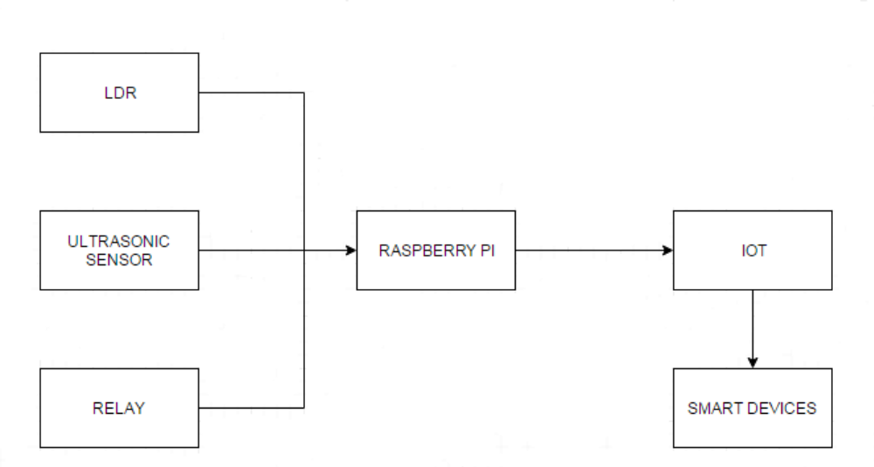
Fig 1.3: Architecture of the proposed system
Limitation
As the code is written in Node JS the problem is that the Application Programming Interface (API) keeps on changing at frequent intervals and does not remain stable.
The codes tend to become clumsy and the programmers must depend on the nested calls.
- Title: Enhanced Home Automation System using the Internet of Things.
Author: S L S Sri Harsha, S Chakrapani Reddy, Prince Mary S
Work implemented
This paper presents a home automation system based on internet of things which works successfully by connecting various appliances and providing the user remote control of the lighting system of their home. The objective of developing this model is to create a home automation system which interacts with the user through various push notifications based on concerned parameters which are also eco-friendly. This System uses a wide array of sensors paired with an application to visualize the sensor data and issue commands to the Home Automation and prompts the user to take appropriate action or initiates a sequence to handle the situation. HAS monitors general household activities such as controlling the lighting, atmospheric conditions, checking the integrity of gates and doors and so forth to provide a safe and comfortable environment for the user to live in.
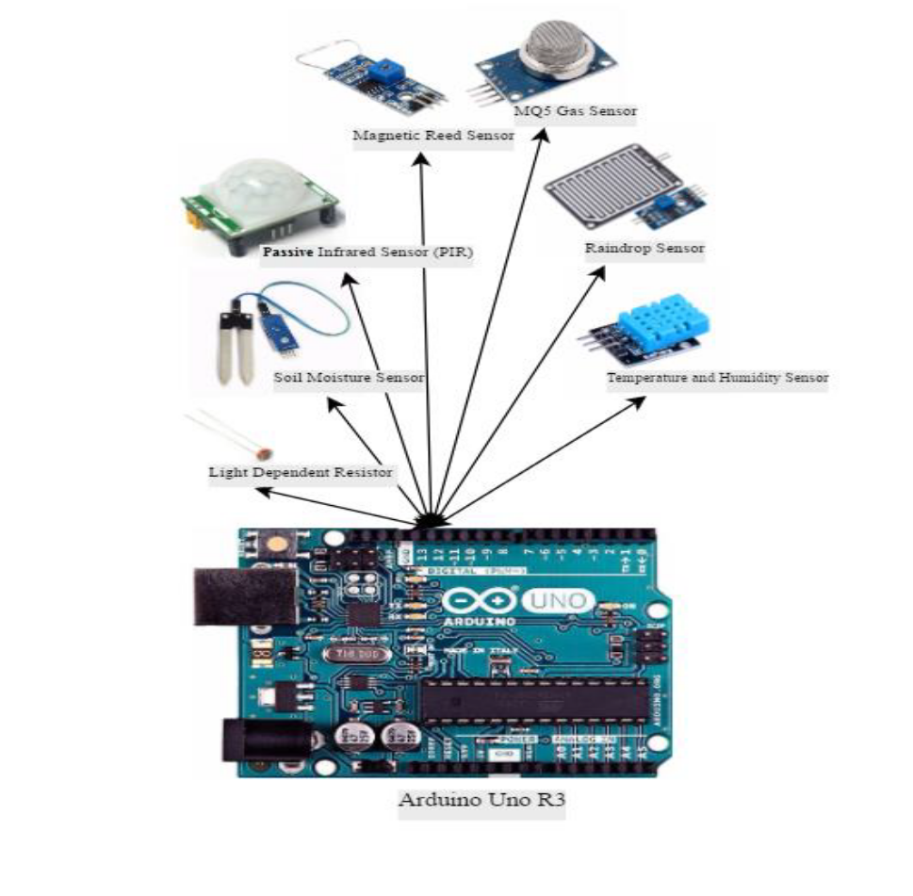
Fig 1.4: System Block Diagram

- Title: IoT base Smart Home Appliances by using Cloud Intelligent Tetris Switch
Author: Ming-Shen Jian, Jun-Yi Wu, Jing-Yan Chen, Yue-Jyun Li, Hao-Yi Xu
Work Implemented
In this system, the cloud Intelligent Tetris Switch is used to achieve the local information exchanging and power control exchanging. The Cloud Intelligent Tetris Switch is the extension of the power line. Based on the embedded system module, each socket of the Switch can be individually controlled. In addition to the manual operation, users can use mobile application or browser to remotely control each socket. It means that each home appliance can be powered on/off remotely according to the command given by the user. Moreover, the Cloud Intelligent Tetris Switch with the embedded system module should connect to the Internet. The Bluetooth, Zigbee, or Wi-Fi is available for communication between Cloud Intelligent Tetris Switch and home appliances / remote home service server. In other words, the communication and data exchanging are achieved.

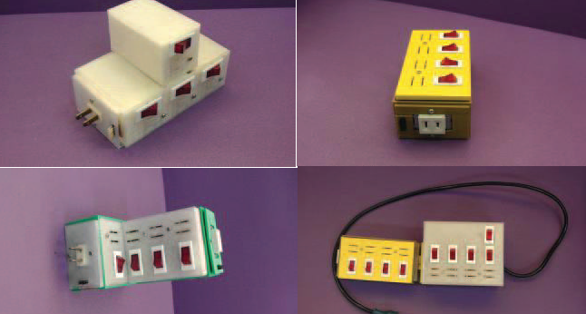
Fig 1.5: The dynamic extension of Cloud Intelligent Tetris Switch
Limitation
For home central server, to dynamically identify each home appliance for executing the same function or service is not possible.

- Title: Sensors in Smart Homes for Independent Living of the Elderly
Author: Pireh Pirzada, Neil White, Adriana Wilde

Work Implemented
This system provides a safe living environment which can identify and predict problems by monitoring the activities of the inhabitants. To handle continuous streams of the data a system is required. Such a system can extract the data by using appropriate algorithms and thus allowing the remote monitoring of the health at a high level. The implementation requires the use of appropriate sensing technologies, identification of ADLs, data pre-processing techniques and machine learning algorithms. This is challenging as there will be many individuals such a system must be able to personalize individual needs. The implementation and design of a platform to smartly monitor the health condition of the elder person using sensor data from a smart home, through an interactive user interface which is user-friendly and multiplatform. This proof-of-concept used off-line data, with the view to extend to real-time data collection in the future, which could then be used to inform support providers remotely.
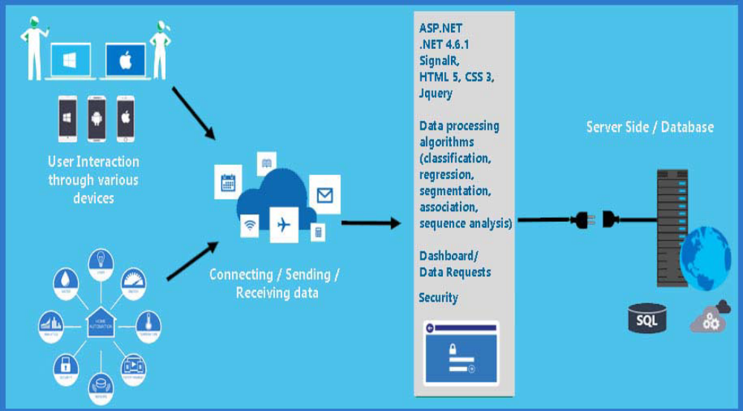
Fig 1.6: Architecture of Smart Home Application

  - Limitations of the Current Work
- When the weather is unpredictable it won't give an accurate result.
- If there is no Internet connection at either end, we need to devise a backup plan for the system.
- Some appliances might not be compatible with the system.
  - Problem Definition
The IoT devices can be controlled manually by the user but, what if it can be controlled through the sensor data? A Machine Learning Algorithm can be implemented by sending the sensor data through the cloud and if the user wants to make changes it should learn and reflect those changes.
  - Objectives
- To control the Appliances from a remote location over the Internet using simple UI.
- To reduce the cost of installation.
- To reduce power consumption.
- To provide convenience to the user
- To provide system scalability
  - Methodology
The proposed system uses the ESP8266 Wi-Fi module which is connected to the sensors and the electronic devices. It uses a Wi-Fi network to connect it from the cloud. The Wi-Fi module sends the Humidity and Temperature data to the cloud which allows the user to monitor the readings. The user can change the speed of the fan and switch ON or OFF the light. Machine Learning Algorithm is used to adjust the electronic devices according to the user behavior. Data from the sensors is stored in a CSV file using python. Using this data, the dataset is being made to make the appliances learn according to the user’s behavior. The DHT11 sensor is connected to the ESP8266 which provides the data in a room.

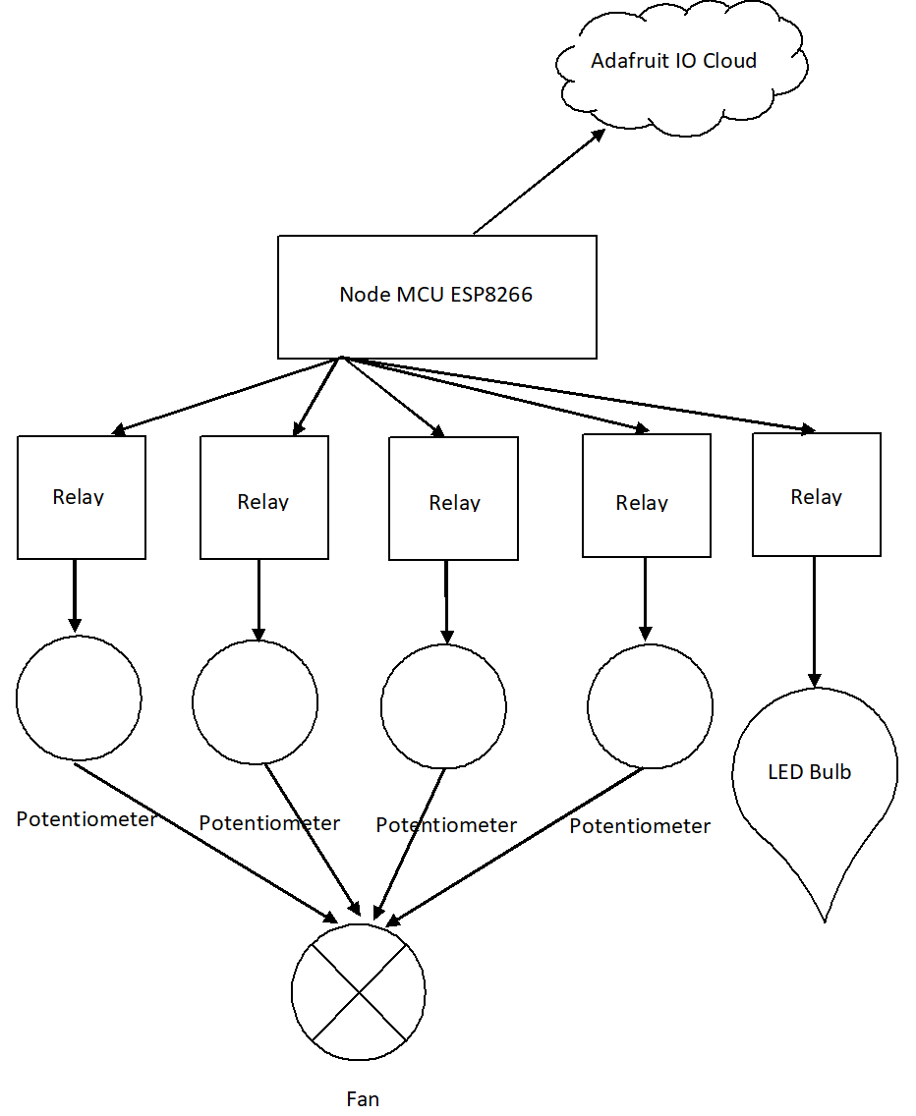
Fig 1.7: Working Model of the Proposed system

  - Hardware and Software Tools Used
    - Hardware tools: ESP8266 Wi-Fi Module, DHT11, 5V Relay, LDR, Potentiometer, LED, Motor.
    - Software tools: Arduino IDE, Adafruit IO, Google Drive.

    - Functional Requirements
The functional requirement in detail are explained below
- SRS_1: The system shall provide a registration page on the UI
- SRS_1.1: Clients fill up their details on the registration page.
- SRS_1.2: Registration takes place by filling details on the UI.
- SRS_1.3: Registered details are stored in a database hosted on the server.
- SRS_2: The system shall provide a login page on the UI.
- SRS_2.1: The user uses their registered username and password to log in.
- SRS_2.2: logged-in users can access Services.
- SRS_3: The system shall support controlling different house devices.
- SRS_3.1: The user must be authenticated to control the devices.
- SRS_3.2: The user must be connected to the specified cloud.
- SRS_4: The system shall support the monitoring of the house and able to regulate the temperature.
- SRS_4.1: Monitoring of the house is done by using Machine Learning Algorithm.
- SRS_4.2: Machine Learning Algorithm will be able to change the speed of the fan and can switch ON or OFF the light.

    - Non-Functional Requirements
Adaptability: As the environment conditions changes, the sensor should detect it. Like the change in temperature is detected by a temperature sensor and so on.
Reliability: The system can perform a required function under stated conditions for a specified period.
Customized: Only authorized users can control the devices.
Modularity: The resulting software companies well defined, independent components. That leads to better maintainability.
Robustness: The system can operate under stress or tolerate unpredictable or invalid input.

Chapter 2
BASIC THEORY

- Basic Theory
Home automation provides access to control devices at home from a mobile device around the world. This term can be used for isolated programmable devices, such as thermostats and sprinkler systems, but home automation more accurately describes homes in which almost everything - lighting, appliances, sockets, heating, and cooling systems - are connected to a remotely controlled network. From the point of view of home security, this also includes an alarm system and all doors, windows, locks, smoke detectors, monitoring cameras and any other sensors that are connected to it.
  - Home Automation Developments
Until recently, automated central control of systems throughout the building occurred only in larger commercial buildings and expensive homes. Typically, using only lighting, heating, and cooling systems, building automation has rarely provided more than basic control, monitoring and planning functions, and was only available from specific control points in the building itself.
Home automation is a step towards the "Internet of Things" in which everything is assigned an IP address and can be monitored and available remotely.
The first and the most obvious beneficiaries of this approach are "smart" devices and devices that can be connected to the local network via Ethernet or Wi-Fi. However, electrical systems and even individual points, such as light switches and electrical outlets, have also been integrated into home automation networks, and companies have even explored the potential for IP-based inventory tracking. Although the day is still a long way, when you can use your mobile browser to track your lost sock, home networks can include an increasing number of devices and systems.
  - Automation
No wonder that automation is one of the two main features of home automation. Automation refers to the programming and event planning capabilities of devices on the network. Programming can include time-related commands, such as switching lights on or off at specific times each day. It may also include unplanned events, such as turning all lights on at home when the security alarm is triggered.
Once you start to understand the possibilities of planning home automation, you can come up with any number of useful and creative solutions to make your life better. Does this west-facing window let through too much light? Connect the motorized blinds to the "smart" socket and program them so that they close every day at noon. Does anyone come every day at the same time to walk the dog? Program your home automation system to unlock the door for them and close them again when done.
  - Remote Control
Another main feature of modern home automation is remote monitoring and access. Although a limited amount of remote one-way monitoring has been possible for some time, only since the emergence of smartphones and tablets we could really connect to our home networks when we are far away. A suitable home automation system allows you to use any device connected to the Internet to view and control the system itself and connected devices.
Monitoring applications can provide a wealth of information about your home, from the state of the current moment to a detailed history of what has happened so far. You can check the status of your security system, whether lights are on, whether the doors are locked, what is the current temperature of the house and much more. Thanks to the cameras as part of the home automation system, you can even download videos in real time and literally see what is happening in your home when you are away.
Even simple notifications can be used to perform many important tasks. You can program the system to send you a text message or e-mail as soon as your security system registers a potential problem, from weather warnings to traffic warnings to fire alarms. You can also be notified of more mundane events, such as programming the "smart" front door lock to let you know when your child will return home from school.
True direct control occurs when you start interacting with the home automation system from a remote application. In addition to arming and disarming the security system, you can reprogram the schedule, lock and unlock the door, reset the thermostat and adjust the lights from your phone from anywhere in the world. Because manufacturers are constantly creating more and more "smart" devices and devices, the possibilities of home automation are virtually limitless.
  - Home Automation Components
What things can be part of the home automation system? Ideally, everything that can be connected to the network can be automated and remotely controlled. In the real world (apart from research laboratories and houses of rich and famous), home automation most often combines simple binary devices. This includes "on and off" devices, such as lights, electrical sockets, and electronic locks, but also devices such as safety sensors that have only two states, open and closed.
Where home automation really becomes "smart", it's about devices with Internet access that join and control the network. The classic control unit is a home computer for which many previous home automation systems have been designed. Today's home automation systems are more likely to distribute programming control and monitoring between a dedicated device at home, such as a security system control panel, and a user-friendly application interface that can be accessed via a PC, smartphone or tablet.
Manufacturers have produced a wide range of "smart" devices, many of which are full of innovative features, but few of them offer the kind of integration necessary to be part of a complete home automation system. Many of the problems were that every manufacturer had a different idea of ​​how these devices should be connected and controlled. So, although you can have a "smart" TV, washing machine, fridge, thermostat, coffee machine or other home appliances available on the market, the result is usually a separate control scheme for each device.
Soon, home automation can be standardized so that we can really take advantage of all these additional opportunities. For now, home security providers specializing in home automation have focused on the most critical and useful parts of the connected home. At the basic level, this means doors and windows as well as environmental devices (thermostat, smoke detectors, temperature, humidity, fire and carbon dioxide sensors) that ensure safety and convenience. To provide additional security, convenience, and real-time control, home automation systems from security providers should also include options for video cameras. Thanks to the best systems you will be able to turn on the lights and individual electrical sockets to the home automation package.
  - Energy Efficiency
One of the clear advantages of home automation is the unmatched potential for energy savings and thus savings. Your thermostat is already "intelligent" in the sense that it uses the temperature threshold to control the home heating and cooling system. In most cases, the thermostats can also be programmed at different target temperatures to keep energy consumption to a minimum during hours when heating and cooling are least likely to be used.
At the most basic level, home automation extends this scheduled programmability to lighting, so you can adjust energy consumption to the usual daily schedule. Thanks to more flexible home automation systems, electrical sockets or even individual devices, you can also automatically switch off during the day when you do not need them. As with isolated devices such as thermostats and sprinkler systems, the schedule can be further subdivided to differentiate between weekends and even seasons in some cases.
Schedules are helpful, but many of us keep different hours from day to day. Energy costs can be further reduced by programming "macros" in the system and remotely controlling them when needed. In other words, you can set up a "home" event that turns on lighting and heating, for example when you go home after work, and activate it all with just one touch of your smartphone. The reverse "leaving home" event can save you from wasting energy on forgotten lights and appliances after leaving the day.

Chapter 3
TOOLS DESCRIPTION

- Tools Description
  - Hardware Tools
    - NodeMCU ESP8266 12E
NodeMCU is a software based on eLua for Espressif ESP8266 Wi-Fi SOC. NodeMCU firmware is a project that accompanies popular sets of NodeMCU devices, ready-made open source development boards with ESP8266-12E chips. The firmware uses the Lau scripting language. It is based on the eLua project and built on the Espressif Non-OS SDK for ESP8266. The following figure shows the basic block diagram of the NodeMCU.
- 10 GPIO pins
- Processor: ESP8266 (LX106)
- Memory: 128 KB
- Memory: 4 MB
- Type: Single-board microcontroller
- Open-source, low cost
- Wi-Fi on
- ESP8266 operates on voltages from 2.8 to 3.5 V, the maximum current consumption is 300 mA.
- The NodeMCU development board has a USB power supply up to 3.3V on the board.
The reason for using NodeMCU in this project is:
- Wi-Fi is on and is inexpensive compared to other devices that support Wi-Fi.
- Supports connectivity with Arduino.
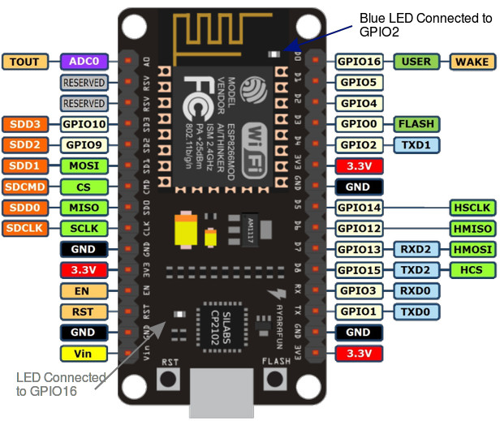
Fig 3.1: NodeMCU diagram
    - Relay Module 4-Ch
The relay is divided into many types, the standard and commonly used relay consist of electromagnets that generally serve as a switch. The dictionary says that a relay means the act of transferring something from one thing to another, the same meaning can be applied to this device because the signal received from one side of the device controls the switching operation on the other side. Thus, the relay is a switch that controls (opens and closes) electromechanical circuits. The main operation of this device is to establish or terminate contact with a signal without human intervention to turn on or off. It is mainly used to control a high-power circuit using a low power signal.
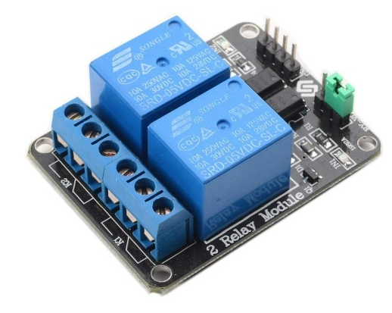
Fig 3.2: 5V Relay diagram
    - LED
A light-emitting diode (LED) is a semiconductor device that emits light when an electric current is passed through it. Light is produced when the particles that carry the current (known as electrons and holes) combine within the semiconductor material.
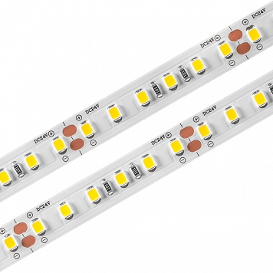
Fig 3.3: LED Strip diagram
Characteristics:
Voltage: 3.2v-3.4v
Typical: 3.2v
Current: 20mA
The reason for using LED in this project is:
- Lower energy consumption
- Longer lifetime
- Improved physical robustness
- Smaller size
    - DHT11 Sensor
The DHT11 sensor is basically a temperature and humidity sensor which is used in embedded projects. Its temperature range is from 0 to 50 degrees Celsius with +-2 degrees accuracy. Its humidity range is from 20 to 80 percent with 5 percent accuracy. DHT11 operates on highly reliable technology and thus provides high stability. It is small, low cost and easy to use.
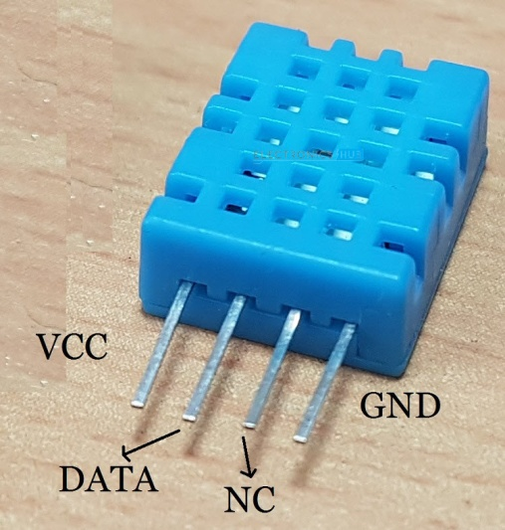
Fig 3.4: DHT11 diagram
Specification
- Operating Voltage: 3.5V to 5.5V
- Operating current: 0.3mA (measuring) 60uA (standby)
- Output: Serial data
- Temperature Range: 0°C to 50°C
- Humidity Range: 20% to 90%
- Resolution: Temperature and Humidity both are 16-bit
- Accuracy: ±1°C and ±1%
The reason for using DHT11 in this project is:
- DHT11 sensor contains both temperature and humidity sensor in the same module.
- Small size, low power, signal transmission distance up to 20 meters.
    - Light Dependent Resistor(LDR)
A Light Dependent Resistor (LDR) or a photoresistor is a device whose resistivity is a function of the incident electromagnetic radiation. Hence, they are light sensitive devices. They are also called as photoconductors, photoconductive cells or simply photocells. They are made up of semiconductor materials having high resistance. There are many different symbols used to indicate an LDR, one of the most commonly used symbols is shown in the figure below. The arrow indicates light falling on it.
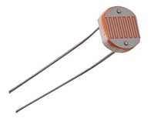
Fig 3.5: LDR diagram
Specification
- Diameter: 5mm
- No. of Pins: 2
- Type of Mounting: PCB Through Hole
- Maximum Operating Temperature: +800C (Approx.)
- Dark resistance:1-20M ohm
The reason for using LDR in this project is:
- It is easy to integrate with lighting system such as automatic lighting system.
- Light sensors need small voltage and power for its operation.
- LDR offers quick response time, lower in cost and provide a digital output.
    - Potentiometer
A potentiometer is a variable resistor. Resistors provide an electrical impedance to current flow, forcing a voltage drop across their terminals. Most resistors have a fixed resistance value, measured in ohms. A potentiometer functions much like a normal resistor, except that its resistance value can be changed, usually by rotating a knob or pushing a slider on the potentiometer structure. Rotational potentiometers, which use a rotating knob to set the resistance, are commonly used to track the rotational position of objects on a shaft. These measurements can be used in many applications, from reading a thermostat’s requested temperature to measuring the position of an accelerator pedal in an automobile.
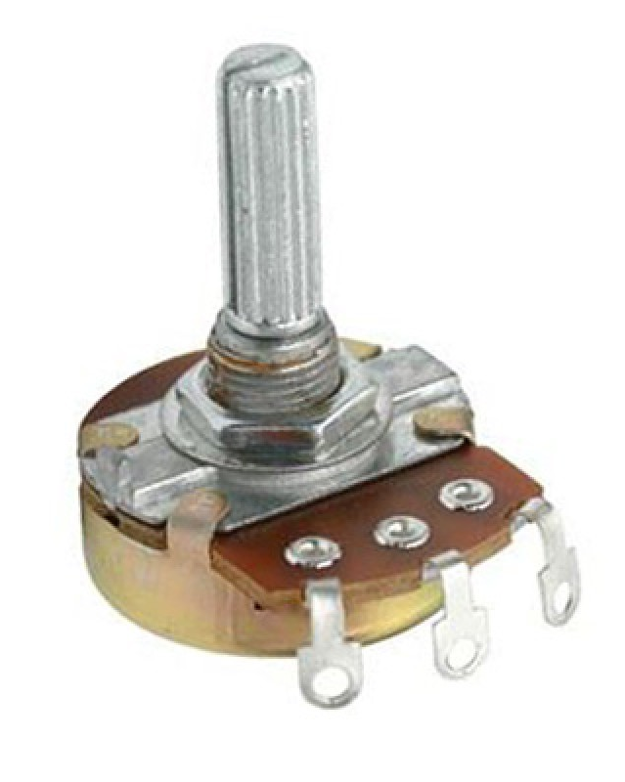
Fig 3.6: Potentiometer diagram
Specification
- Power Rating: 0.3W
- Maximum Input Voltage: 200Vdc
- Rotational Life: 2000K cycles
- Resistance: 10K ohm
The reason for using Potentiometer in this project is:
- We use 4 Potentiometers in this project for controlling the voltage input to the fan.
- The speed of the fan can be controlled by varying the resistance.
    - Motor
It is an electrical machine that converts electrical energy into mechanical energy. Most motors operate through the interaction between the motor's electric current and magnetic field in a wire winding to generate force in the form of rotation of a shaft. The motors are powered by direct current (DC) sources, like batteries, motor vehicles or rectifiers, or by alternating current (AC) sources, such an inverter, a power grid or an electrical generator. An electric generator is mechanically identical just like an electric motor, but operates in the reverse direction, changing mechanical energy into electrical energy.
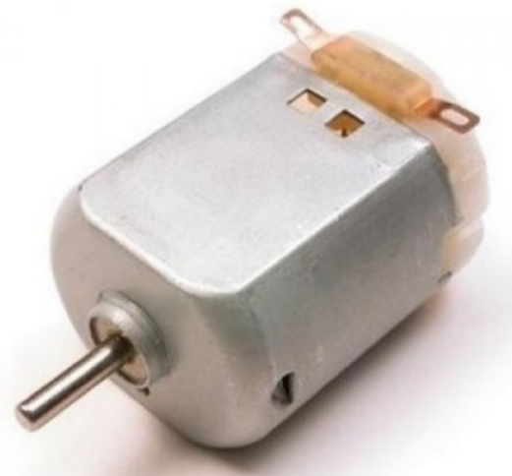
Fig 3.7: Motor diagram
  - Software Tools
Software tools are used to create, debug, maintain otherwise support other program and applications. It performs productive tasks for the user such as word processing and database management. The different software tools used are Arduino IDE, IDLE, etc.
    - The Arduino IDE
Arduino IDE is a platform for open-source electronics prototyping, based on flexible, easy-to-use hardware and software. It is intended for artists, designers, hobbyists, and anyone interested in creating interactive objects or environments. Arduino can sense the environment by receiving inputs from various sensors and can affect the surroundings by controlling lights, motors, and other executive elements. The microcontroller on the board is programmed using the Arduino programming language (based on Wiring) and the Arduino programming environment (based on processing). Arduino projects can be independent or can communicate with software running on a computer.
The boards can be built manually or bought in a pre-assembled state, the software can be downloaded free of charge. Hardware reference projects (CAD files) are available under an open-source license, you can customize them to your needs. Arduino Integrated Development Environment (IDE), which is cross-platform written in the C programming language. It comes from IDE for Processing and Wiring languages. It includes a code editor with functions such as cutting and pasting text, searching and replacing text, automatically pushing, matching curly brackets and syntax highlighting, as well as providing simple mechanisms for compiling and transferring programs to an Arduino disc once. It also contains a message area, a text console, a toolbar with a button for common functions and an operation menu hierarchy. A program written with an IDE for Arduino is called a sketch. Sketches are saved on the programmer's computer as text files with the file extension. Sketches of Arduino Software (IDE) with pre-1.0 with extension.
Arduino IDE supports C and C ++ languages, using special rules for code structuring. Arduino IDE provides a software library from the Wiring project that provides many common entries and exit procedures. The code written by the user requires only two basic functions to run the sketch and main program loop, which is compiled and connected to the main () main program in an executable recurring executive program from GNU toolchain, also included in the IDE distribution.
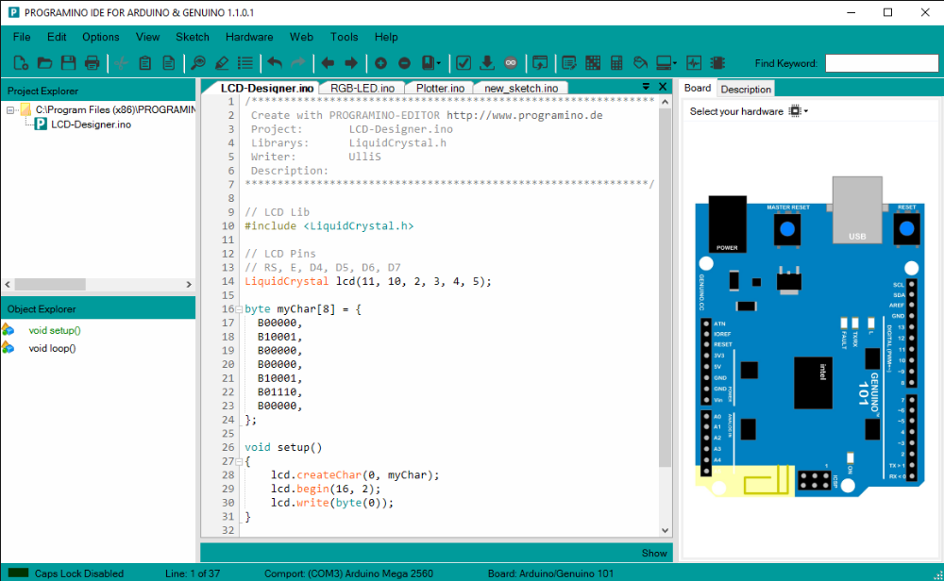
Fig 3.8: Arduino IDE

    - IDLE
IDLE (Integrated Development Environment or Integrated Development and Education Environment) is an integrated development environment for Python that has been included in the default language implementation. It is packaged as an optional part of the Python package with many Linux distributions. It is completely written in Python and the Tkinter GUI (packaging functions for Tel / Tk). IDLE is meant to be a simple IDE and is suitable for beginners, especially in an educational environment. For this purpose, it is a cross-platform platform and avoids the clutter of functions.
    - Cloud
Cloud storage is a data storage model in which digital data is stored in logical pools, the physical store includes multiple servers (and often locations), and the physical environment is usually owned and managed by the management company. Cloud storage providers are responsible for ensuring the availability and availability of data, and the physical environment is protected and works. People and organizations buy or lease memory capacity from suppliers to store user data. Access to cloud storage services can be obtained through a shared cloud computing service, an internet application programming interface (API) or API-based applications such as cloud storage, a cloud storage gateway or online content management systems.
Cloud storage is:
- It consists of many scattered resources, but still works as one in a federated or co-operative cloud architecture.
- High resistance to damage due to redundancy and data distribution.
- Very durable due to the creation of a copy of the version.
- Usually consistent for data replicas.
    - Adafruit IO
Adafruit IO is a cloud facility that means that the facility is run for the end user and the end user does not have to manage it. It can be connected via the Internet. It is designed primarily for storing and then downloading data, but it can do much more.
What Adafruit IO can do
- View the information in real time, online
- Connect the project to the internet: reading data from sensors, control engines, and many things can be done.
- Combine the projects with online services such as RSS feeds, Twitter, weather services, etc.
- Combine the project with other devices that have internet access
- The best part of Adafruit IO is that this is possible for free.
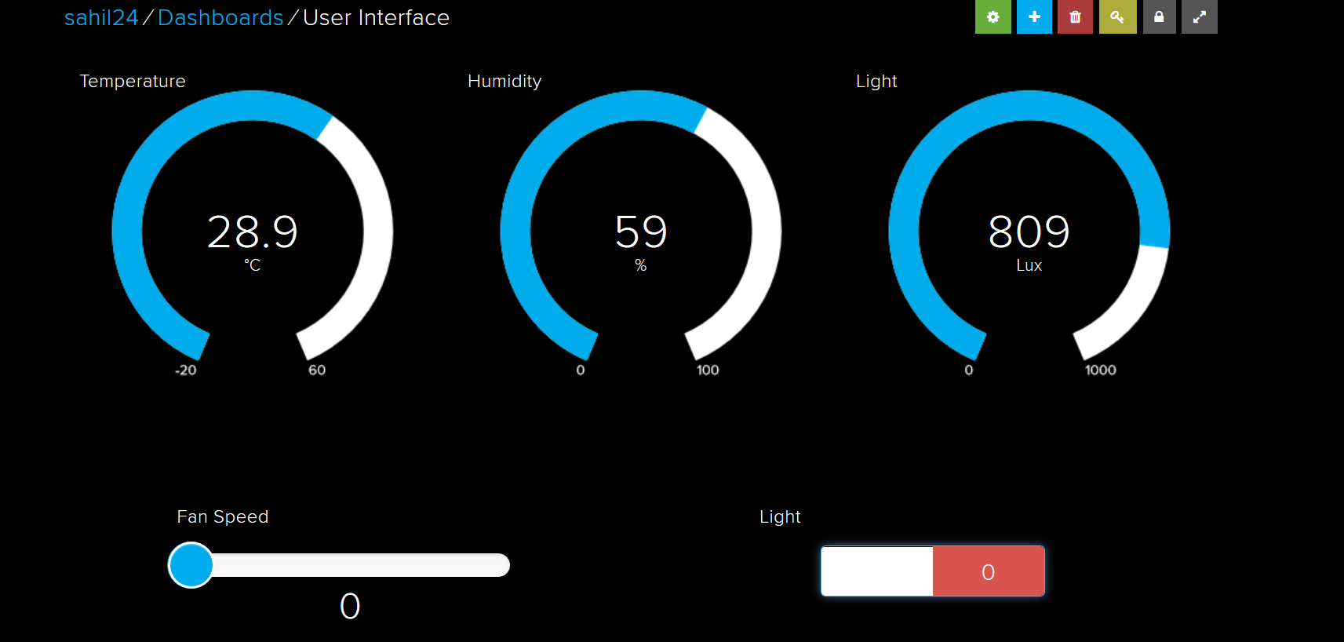
Fig 3.9: Adafruit IO Dashboard
It can handle and visualize many data sources, and if the user wants to display information from the humidity and temperature sensor next to the air quality sensor and add a button to turn on the air conditioner, the control panels are integrated with the Adafruit IO that allows the end user to create charts, graphs, measurements, data logging, and display. The end user can browse the dashboards from anywhere in the world.
    - Advantages of Cloud
- Companies only must pay for the storage they use, usually the average consumption per month. This does not mean that the storage of data in the cloud is cheaper, only that it incurs operating costs, not a capital expenditure.
- Companies using mass storage in the cloud can reduce energy consumption by up to 70%, which makes them more organic. In addition, at the supplier level, they are dealing with a higher level of energy, so they will be better equipped with management to maintain their own costs.
- Availability of mass storage and data protection are inextricably linked to the architecture of object storage, so depending on the application, additional technology, effort and the cost of adding accessibility and protection can be eliminated.
- Mass storage maintenance tasks, such as the purchase of additional storage capacity, are transferred to the service provider's liability.
- Cloud storage provides users with instant access to a wide range of resources and applications hosted on the infrastructure of another organization through the web service interface.
- Cloud storage can be used to copy virtual machine images from the cloud to local locations or to import a virtual machine image from a local location to the cloud image library. In addition, cloud storage can be used to transfer virtual machine images between user accounts or between data centers.
- Cloud storage can be used as a disaster-proof backup because there are usually two or three different backup servers in different backup servers located in a different location around the world.

Chapter 4
IMPLEMENTATION

- Implementation
Implementation is the realization of a technical specification or algorithm as a program, software component and another computer system through programming and deployment. Many implementations may exist for a given specification or standard. System implementation generally benefits from higher levels of user involvement and management support. User participation in the design and operation of information systems has several positive results. First, if users are heavily involved in systems design, they move opportunities to meld the system according to their priorities and business requirements, and more opportunities to control the outcome. Second, they are more likely to react positively to the change process. Incorporating user knowledge and expertise leads to better solutions.
The relationship between the user and the designer has traditionally been a problem in the implementation of the software. Users and Information systems specialist tend to have different concerns.
User Concern
- Will the system deliver the information I need for my works?
- How quickly can I access the data?
- How easily can I retrieve the data?
- How much clerical support will I need to enter data into the system?
- How will the operation of the system fit into my daily business schedule?
  - IoT Home Automation: Getting Started
Home automation has three major parts:
Hardware
Software/Apps
Communication protocols
Each of these parts is equally important in building a truly smart home experience for your customers. Having the right hardware enables the ability to develop your IoT prototype iteratively and respond to technology pivots with ease.

A protocol selected with the right testing and careful consideration helps you avoid performance bottlenecks that otherwise would restrict the technology and device integration capabilities with sensors and IoT gateways.
Another important consideration is the firmware that resides in your hardware managing your data, managing data transfer, firmware OTA updates, and performing other critical operations to make things talk.
  - Project Overview
Smart Home system uses three loads to demonstrate as house lighting. Our user-friendly interface allows a user to easily control these home appliances through the internet. For this system, we use a Wi-Fi Module as a controller and a 5V relay. This Module is used to get user commands over the internet. 5V Relay switch is used to send control signals from the Wi-Fi Module to the electronic device used to achieve the switching on and off action. A web portal named Adafruit IO is designed with a one-factor authentication system (username and password) to check the authenticity of the home user. It acts as an input device to control the home appliances and acts as an output device to read the values of the physical conditions. Hardware Circuit is powered by using a USB cable from laptop. After receiving user commands over the internet, Node MCU processes these instructions to operate these loads accordingly and display the system. Thus, this system allows for efficient home automation over the internet.
  - System Architecture
The core of the home automation system is Node MCU ESP8266 which is a small size, low-cost microcontroller. It can easily interact with the outside world and is compatible with the C language. The Wi-Fi module is used in the project which is controlled by Arduino IDE when we upload the code, making use of an ARM architecture. All the components are connected to the Wi-Fi module which controls their functioning. The LDR is used to detect the presence or absence of light and it works on the principle of photoconductivity. DHT11 sensor detects the current Humidity and Temperature of the room. A relay is an electromagnetic switch operated by relatively small electric currents that can turn on/off much larger currents. Finally, the Wi-Fi module acts as a web server and cloud interface is used to control the relay. Router is used for communication between the devices.
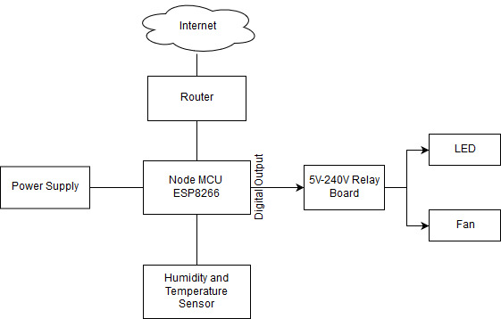
Fig 4.1: System Architecture of Home Automation

  - Circuit Diagram
NodeMCU is a system on a chip, DHT11 is connected to board using Digital pin D1 and LDR sensor is connected to board using Analog pin A1 .5v 4 Relay module is connected to NodeMCU using pins from D2 to D5 and a 5v Relay module is connected to pin D6. These relays are used to control the voltage output for the electrical appliances. 4 Potentiometer with 10K Ohm resistance is connected to 4 Relay modules in series. The potentiometer is connected to a dc motor, Potentiometer is used to control the speed of the dc motor. Speed of the DC motor is controlled by using the data of DHT11 sensor (temperature and humidity). 1 The relay module is connected to the LED strip. The LED strip will be turned OFF or ON based on the LDR sensor input. NodeMCU is powered up using a 9V battery and one more 9V battery is used to power up dc motor and led strip.
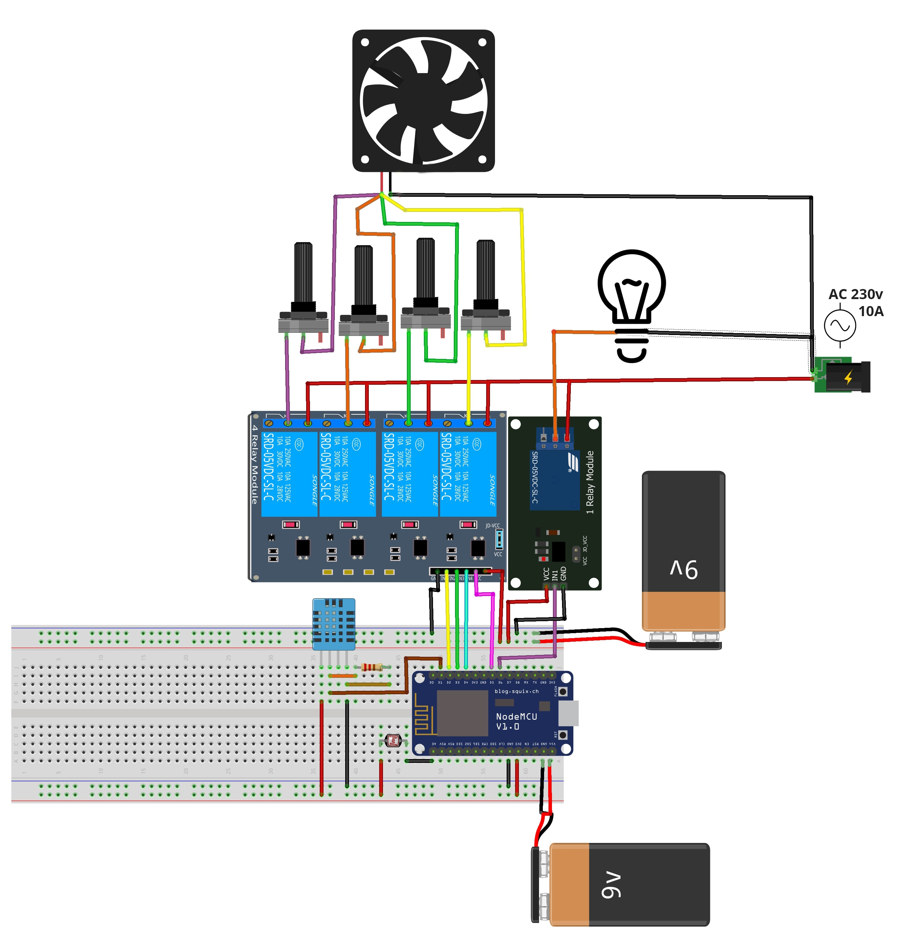
Fig 4.2: Circuit Diagram

  - Flow Chart
The NodeMCU ESP8266 12E is the SOC used to connect the various components of the system, such as the sensors and the cloud used to process the information.
The NodeMCU gets the data from the LDR and the humidity & temperature sensor (DHT11) and sends it to the cloud (Adafruit IO) with the help of MQTT (Message Queuing Telemetry Transport).
The Adafruit IO applies an algorithm on the received data and according to the output generated, it changes the fan and light intensity according to the given sensor data.
These changes are then relayed back to the NodeMCU, which changes the status of the fan and light.

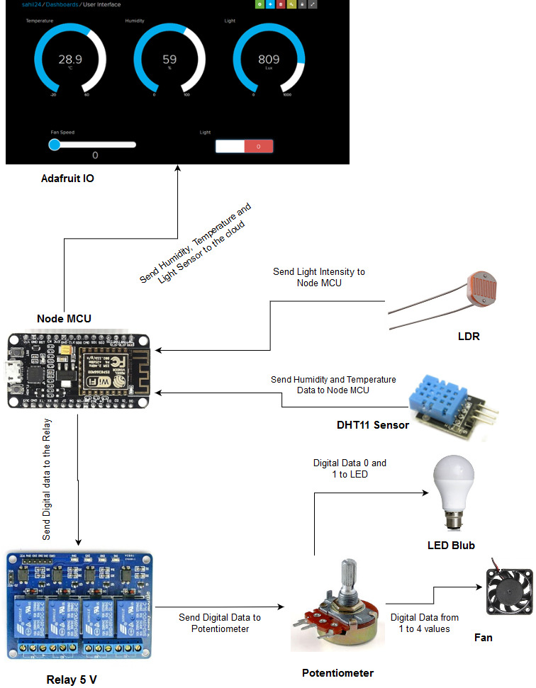
Fig 4.3: Flow diagram of Home Automation

  - Implementation Steps
Step 1: To establish a connection between the client and the server, the Wi-Fi option in the Smartphone is enabled.
Step 2: It is connected to the Wi-Fi module of the system.
Step 3: Each electronic/electrical appliance in the system is connected to the digital pins on the Wi-Fi Module.
Step 4: A Relay is used for connecting each device to the Node MCU, which helps in converting high Voltage supply to low voltage.
Step 5: A C-program is loaded on to the microprocessor chip on the Node MCU which specifies what action is to be performed on receiving inputs.
Step 6: A Cloud Interface is developed which enables the end user to monitor and control the appliances from any remote location.
Step 7: Socket Programming has been used to achieve client-server communication.
Step 8: Successful controlling and monitoring of appliances.
  - Software Algorithm
Information about the surrounding light is given by the LDR, and the temperature and humidity data are provided by the DHT11 sensor.
The algorithm used changes the intensity of light and fan according to the received sensor data.
For example, if the surrounding light drops below a certain threshold, the light gets turned on.
Similarly, if the humidity and temperature of the surroundings rise above a certain threshold, the fan intensity will increase. Also, the intensity will decrease if the humidity and temperature fall below a certain threshold.

Chapter 5
Software Design

- Software Design
Software Design of the System shows the interactions between the different modules of the system and the communication pattern between them. It also shows which module is active for what duration of time. The different method of representing software design is Data flow diagram, Sequence diagram and Use Case diagram.
  - Data Flow Diagram
The Data flow diagrams (DFDs) is the graphical representation of a system that shows the inputs to the system, the processing upon the inputs, outputs of the system as well as the internal data stores. DFD illustrates the series of transformations or computation performed on the objects or the system. system.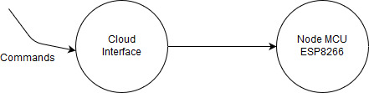
Fig 5.1: Level 0 Data Flow Diagram

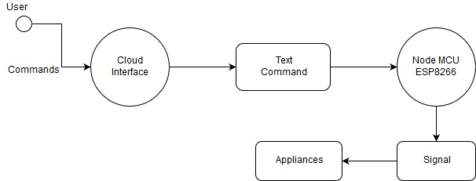
Fig 5.2: Level 1 Data Flow Diagram
The data flow diagram shows what kind of information will be input to an output from the system, where the data will come from and go to, and where the data will be stored. It does not show information about the timing of the process, or information about whether the process will operate in sequence or in parallel.
Fig 5.1.1 shows the level 0 DFD, level 0 DD’s will give an overview of the whole system. The input to the system is given by the user who is the sender, the publisher users broker and at the receiver side, the message is obtained safely. Fig 5.1.2 explains how the client logins into his account. After his successful login, the user is provided with varies features where he can control devices through UI like android app or a Web interface.
  - Sequence Diagram
A sequence diagram is an interaction diagram that shows how processes operate with one another and what is their order. A sequence diagram shows object interactions arranged in time sequence. It depicts the objects and classes involved in the scenario and the sequence of messages exchanged between the objects needed to carry out the functionality of the scenario. The below diagram will show us how the commands are been carried out from one module to another module to control appliances. The user will send the voice commands the cloud later the application will convert that voice commands to text form which are later sent to NodeMCU to control appliances.
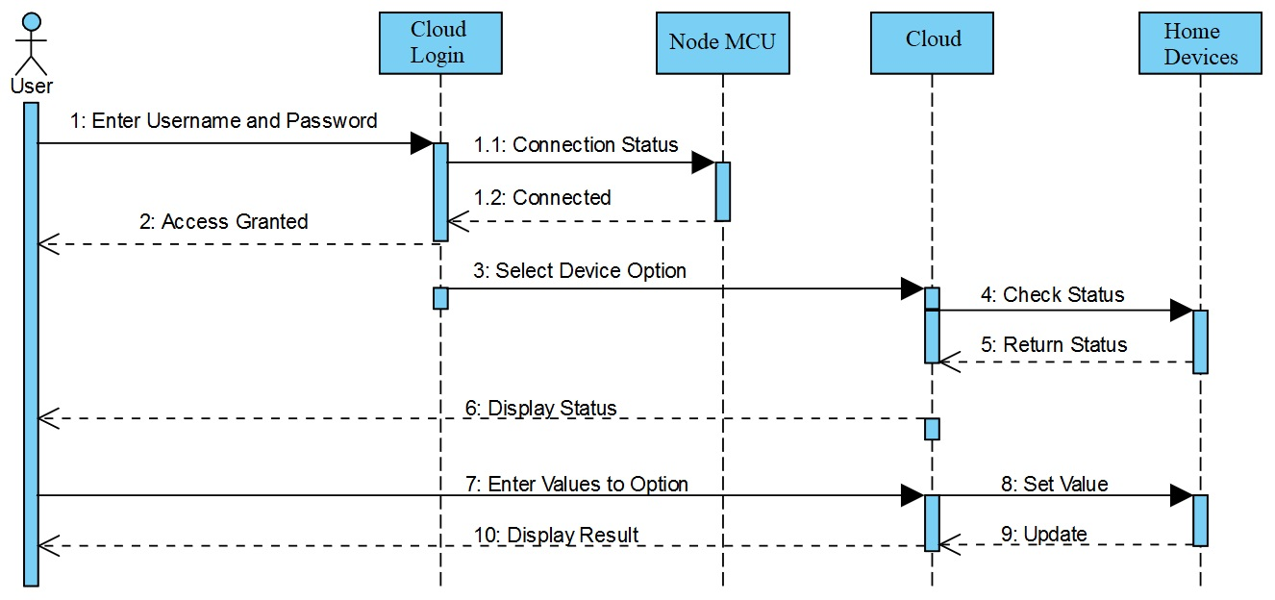
Fig 5.3: Sequence Diagram

  - Use Case Diagram
A use case diagram is a graphic depiction of the interactions among the elements of a system. A use case is a methodology used in system analysis to identify, clarify, and organize system requirements. Use case diagram shows the communication between the actor and system. In our system actor is a user who will just open the application and click on the icon and gives the voice commands and these commands are been converted to text and been sent to the Node MCU later the appliances are been controlled according to the given voice commands.

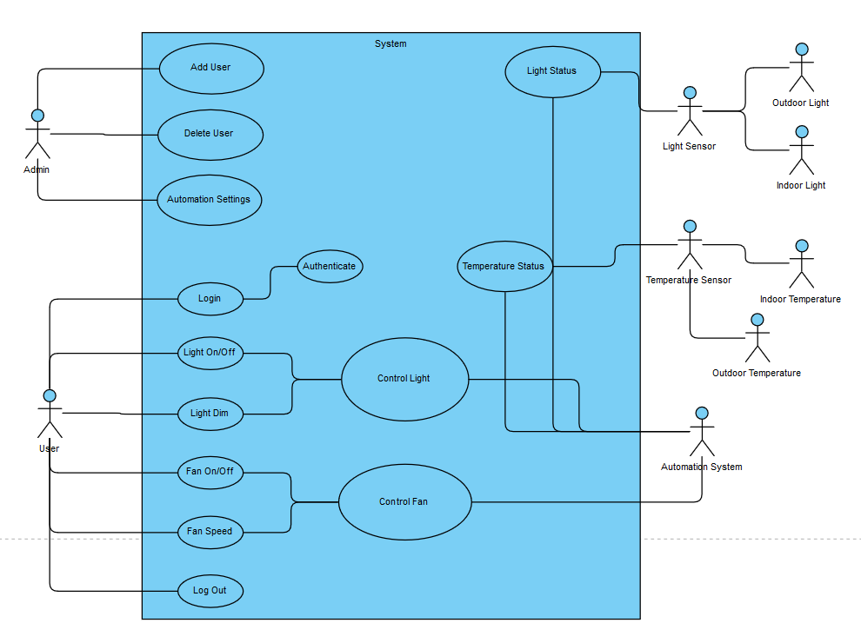
Fig 5.4: Use Case Diagram
  - Activity Diagram
An Activity Diagram is used to illustrate the flow of control in a system and it refers to the steps involved in the execution of the use case. The sequential and concurrent activities are model using activity diagrams. So, we basically depict workflows visually using an activity diagram. An activity diagram focuses on the condition of flow and the sequence in which it happens. We describe or depict what causes an event using an activity diagram.
UML models basically three types of diagrams, namely, structure diagrams, interaction diagrams, and behavior diagrams. An activity diagram is a behavioral diagram i.e. it depicts the behavior of a system.
An activity diagram portrays the control flow from a start point to a finish point showing the various decision paths that exist while the activity is being executed. We can depict both sequential processing and concurrent processing of activities using an activity diagram. They are used in business and process modelling where their primary use is to depict the dynamic aspects of a system.

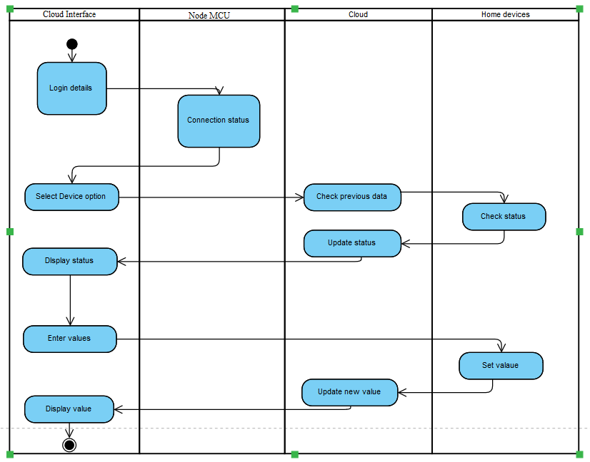
Fig 5.5: Activity Diagram

  - Testing Diagram
In this diagram individual components are tested. The purpose is to validate that each unit of the hardware and the software performs as designed. A unit is the smallest testable part of any software. It usually has one or a few inputs and usually a single output. In procedural programming, a unit may be an individual program, function, procedure, etc. In object-oriented programming, the smallest unit is a method, which may belong to a base/ super class, abstract class or derived/ child class. (Some treat a module of an application as a unit. This is to be discouraged as there will probably be many individual units within that module.) Unit testing frameworks, drivers, stubs, and fake objects are used to assist in unit testing.
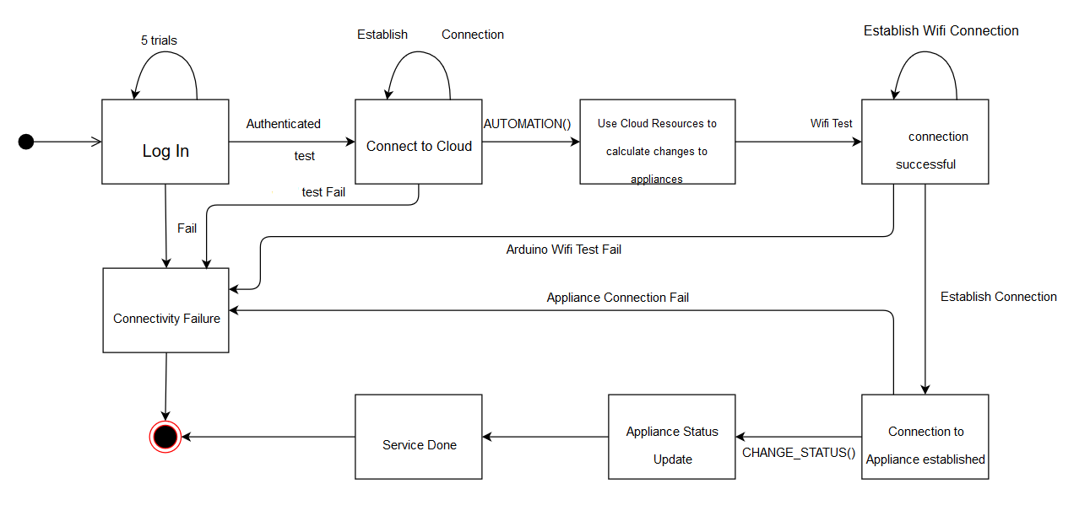
Fig 5.6: Testing Diagram

Chapter 6
RESULTS AND SNAPSHOTS

Chapter 6
- Result and Snapshots
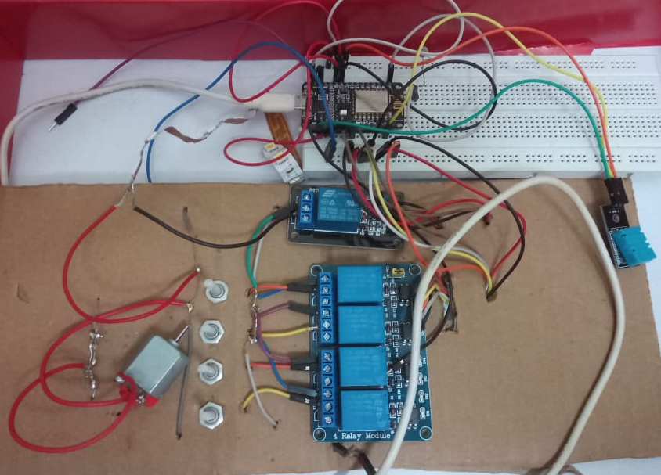
Fig 6.1: Hardware Connections
The above Figure 6.1 shows the experimental setup of the project, A NodeMCU, DHT11, LDR are connected to each other. The NodeMCU is connected to the Relay which is of 5V each. The 4 relays are used to control the speed of the fan and other 1 relay is used to switch “ON” or “OFF” the LED. Relay is then connected to the potentiometer for controlling the flow of current as it provides resistance. The potentiometer is connected to the fan due to which the speed of the fan can be controlled. In the above circuit, two batteries are required, 1 for powering the circuit and other for powering the devices.
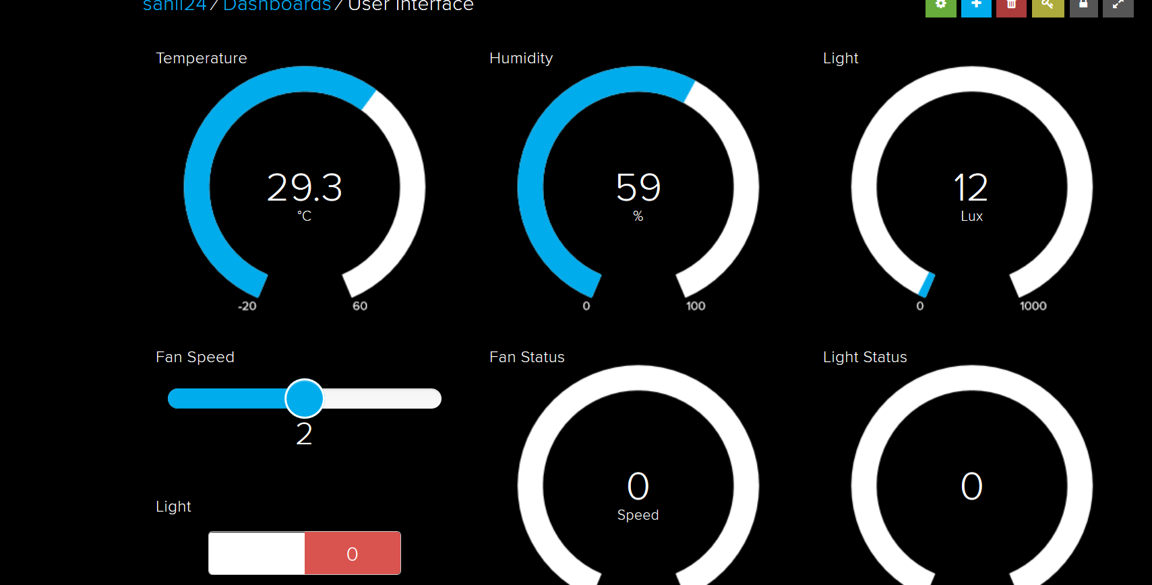
Fig 6.2: Cloud Interface
The above Figure 6.2 contains the user interface which is used to monitor the sensor data and used to control the electronic devices. The above interface contains feed of “Temperature, Humidity and Light” which is used to display the current values that are sent from the sensor. The feed “Fan Speed” and Light are used to control the speed of the fan and switch “ON” and “OFF” the light. The feed “Fan Status” and “Light Status” is used to display the status of the fan and LED. To use the interface, the user must log into the cloud with the help of credentials which makes the interface secure and easy to use.
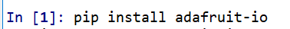
Fig 6.3: Python command to connect to Cloud
Install python spyder and use the above command to connect the IDE with the cloud. When the packages are installed with this IDE the will be able to receive the sensor data in the form of a string and that data can be used to implement machine learning.
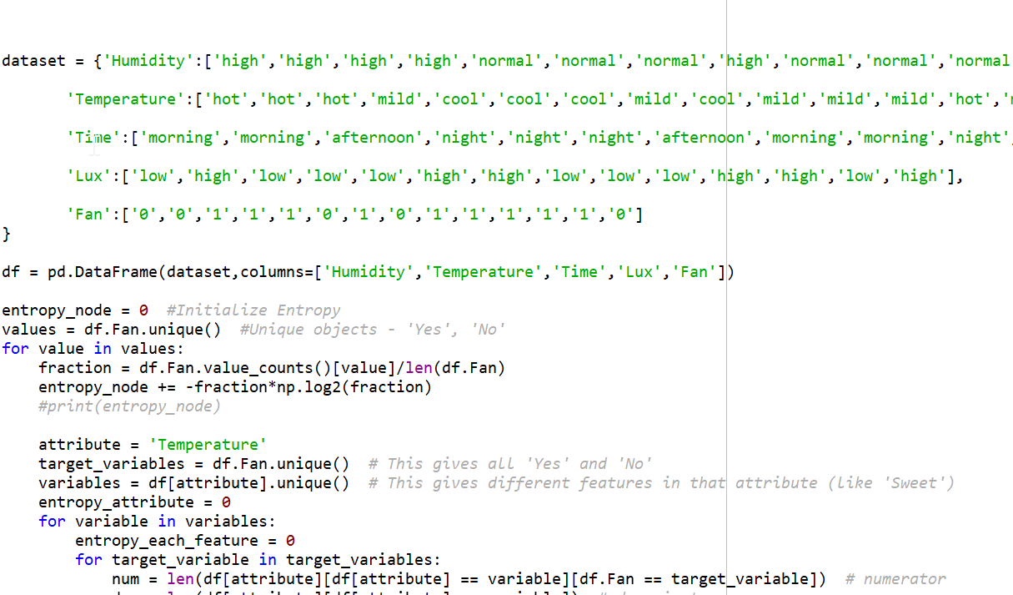
Fig 6.4: Data set and Algorithm
After connecting to the cloud, a decision tree which is the part of the machine learning algorithm is implemented. The dataset here is trained and the output is generated in binary form i.e. 0 and 1 or ON or OFF. The output is dependent on the parameters which are Humidity and Temperature.

CONCLUSION AND FUTURE
SCOPE

Conclusion
The project, in general, has been successfully implemented. The software produced for the project is functionally correct, reasonably robust, and usable. The project has met the entire General and Non-Functional Requirements and in addition, has been implemented in a modular fashion, which can be easily modified or rewritten at a later stage. The user interface is easy to use and works in all web browsers. It does not require any propriety interfaces or plug-ins to operate. This means that the Home Automation System is accessible from any web browser and that the system could be usable from anywhere on the Internet and therefore from anywhere on the planet. The software is robust. The design of the software means that most errors are caught in a non-fatal manner, meaning that the software can continue executing even after a bad request.
The proposed system can be further used for enhancements can be like
- Securing the data transfer and add other security measures.
- An advance machine learning algorithm for the device can also be applied.
- Applying the system for managing traffics smart cities, etc.

Future Scope
As the software was being developed, several minor shortcomings in the system were found. There are several changes to the design that could be considered in future additions to the software:
- Due to the nature of the type of module used in this project, the module did not have the ability to respond to a request for status, so it is not possible to query devices for status when the Home Automation System is first started. Therefore, when the system starts, the status of devices is at first unknown, and so is assumed to be ‘Off’ for each device.
- The performance of the software is something that could also be improved by optimizing the code if given more time. The performance gains to do this however would only be noticeable on very slow connections to the Internet.
- Future scope of this project will include making smart home automation system that could detect the presence of someone in a room, through sensors and manage the appliances accordingly. This will also help towards conservation of energy and increasing the lifetime of the appliances.
- Because of the hardware limitations of the Wi-Fi Module, there are only a fixed number of devices that can be attached to the system. Further work will include trying to design hardware that can easily be expanded or accommodate many devices.
The changes mentioned here would not be too complex to implement. The modular design of the system would allow for changes to be made without significant changes to the existing code.

